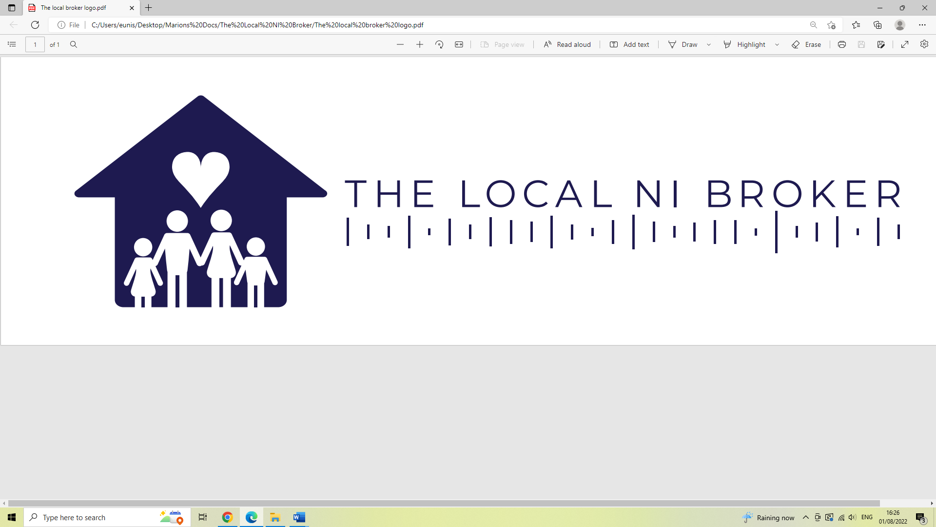

TERMS OF BUSINESS

About this document
This document outlines our terms; it is provided to consumers considering financial services and products. You need to read this important document. It explains the service we provide and the costs associated.
By choosing to transact business with us, you are agreeing to accept and be bound by the terms included in this document.

How we are regulated
The Local NI Broker Limited is an appointed representative of The Right Mortgage Limited who are authorised and regulated by the Financial Conduct Authority (FCA) for general insurance, private medical insurance and pure protection business You can check our details and regulatory permissions via the Financial Services Register at register.fca.org.uk/ or by contacting the FCA on 0800 111 6768. Our FCA reference number is 979768.

Our company
The Local NI Broker Limited of Unit 3 Balliniska Business Park, 18 Balliniska Road, Londonderry, Northern Ireland, BT48 0NA trades as a limited company. Our Company Number is: NI689350.
We offer an advised service for insurance. This means that we will provide you with a recommendation for you after we have assessed your needs.

How we use your data
As part of our advisory process, we will ask you a number of questions that relate to your personal and financial circumstances, including questions regarding potentially sensitive personal data such as physical and mental health questions.
Only information that is relevant to your financial planning needs will be gathered and stored. Full details of the information gathered and how we use your information is included in our Privacy Notice.
Information is gathered on a ‘contractual’ basis, which means that we will ask for relevant information to ensure we are able to carry out our responsibilities under the terms of this agreement.
“Processing” includes obtaining, recording or holding information or data, transferring it to other companies associated with us, product providers, the Financial Conduct Authority or any other statutory, governmental or regulatory body for legitimate purposes including where relevant to solicitors and/or other debt collection agencies for debt collection purposes and carrying out operations on the information or data.
We will retain this information for as long as is necessary to fulfil our regulatory and legal responsibilities, this includes for the purpose of defending any future complaints that may arise and to assist you to understand the products you have purchased should your own records be unavailable. The retention of this data can also be beneficial for the purpose of assisting you with future insurance claims (should you have purchased a product from us).
We will treat all personal data and sensitive personal data as confidential. Steps will be taken to ensure that the information is accurate, kept up to date and not kept for longer than is necessary. Full details of how we use your personal data is contained in our Privacy Notice.
We have also taken measures to safeguard against unauthorised, or unlawful processing and accidental loss or destruction or damage to the data.

Insurance Products
We offer products from a fair analysis of insurers for pure protection (non-investment) insurance contracts. For example; life, critical illness and income protection insurances.

We offer products based upon a fair analysis of general insurance providers for:

- Property, contents, personal possessions cover;
- Accident, sickness & unemployment cover;
- Private medical insurance cover.

A list of the insurers with whom we transact business is available on request.

What we will do
- Act on your behalf and in your best interests;
- Communicate clearly, promptly and in plain English;
- Explain all costs involved before they are incurred;
- Evaluate your needs before making a recommendation;
- Review the market from our list of providers to recommend the most suitable product and provider for your needs and circumstances;
- Deal with reputable providers of insurance products; however, we cannot be responsible for their levels of service, including any delays in processing of your application caused by the product provider. Of course, we will work to mitigate these wherever possible.

What we will not do
- Provide a decision in principle before conducting a thorough review of your circumstances and needs (fact find) and obtaining sufficient supporting information to assist the application;
- Cause you to incur a credit search without first notifying you;
- Act without first obtaining your permission to do so;
- Cause you to incur costs without your prior agreement to proceed.

How we will operate
During our initial consultation we will complete a client questionnaire (fact find) to enable us to better understand your circumstances and your needs; this enables us to give appropriate advice on your insurance needs. A copy of this questionnaire is available for you to review upon request.
We will subsequently conduct research to establish what products are most appropriate for your needs and make these recommendations to you. These recommendations will be confirmed in writing as the advice we provided.
You will also be provided an illustration regarding the product(s) recommended.

Costs
Insurance

- No fee is payable for our service in relation to insurance contracts;
- We will be paid commission by the insurer.

Complaints
If you wish to register a complaint, please contact us:
In writing: The Right Mortgage Limited, St John’s Court, 70 St John’s Close, Knowle, B93 0NH.
By phone: 01564 732 744
If you cannot settle your complaint with us, you may be entitled to refer it to the Financial Ombudsman Service. www.financial-ombudsman.org.uk

Your responsibilities
It is your responsibility to deal with us in an honest and transparent manner. Failure to disclose key facts that relate to your personal circumstances could significantly influence the advice given. In some circumstances failure to disclose information could impact upon your ability to obtain the most suitable product and could even invalidate the product, such as in the event it is interpreted as material non-disclosure that could be considered to be a fraudulent act.
If you have any doubts as to whether you should disclose a matter it is better to notify the provider and allow them to make an informed decision.
It is also your responsibility to check that the product provided is as you expected, therefore you should check the application and ‘offer’ document on a mortgage and the application and policy document on an insurance policy. If it is not as expected, please notify your adviser immediately.

Financial Services Compensation Scheme (FSCS)
Insurance advising & arranging
For firms declared in default on or after 8 October 2020:
Protection is at 100% where claims:
- arise in respect of a liability subject to compulsory insurance; or
- arise in respect of a liability subject to professional indemnity insurance; or
- arise from the death or incapacity of the policyholder due to injury, sickness, or infirmity including contracts for Long Term Insurance such as Long-Term Care, pensions and annuities; or
- arise in respect of a liability subject to building guarantee policies.
Protection is at 90% where claims arise under other types of policy with no upper limit.

Cancellation rights
Depending on the product provided you will have different cancellation rights; these will be explained to you as part of our advisory process and will be disclosed to you by the provider in their communications also. It is your responsibility, however, to exercise these rights in a timely fashion; we cannot do this on your behalf.

Instructions
We will normally accept your instructions verbally or in writing; however, we always recommend that all instructions are provided in writing for the avoidance of misunderstandings.

Client money
WE DO NOT HANDLE CLIENT MONEY. We will not accept any cheque other than for the payment of your fee, any third-party payments must be made by you to them. Under no circumstances will we handle cash.

Call recording
Telephone calls made to The Local NI Broker Limited may be recorded and used for training and/or regulatory purposes.

Conflicts of interest
We undertake not to transact business where we believe that to do so could result in a conflict of interest. Where we believe that our interests conflict we will notify you in writing first and outline the basis upon which we are prepared to proceed. The decision to proceed will be yours however.

Declarations
By proceeding to supply your personal details as part of our ‘fact finding’ process, you are agreeing:
- To be bound by the terms and conditions of this agreement.
- That, where appropriate, we may forward your information on to, necessary, ‘third parties,’ such as insurance providers, to facilitate the provision of any products as agreed with you.
- That, the insurer we approach on your behalf, may conduct a credit search.

